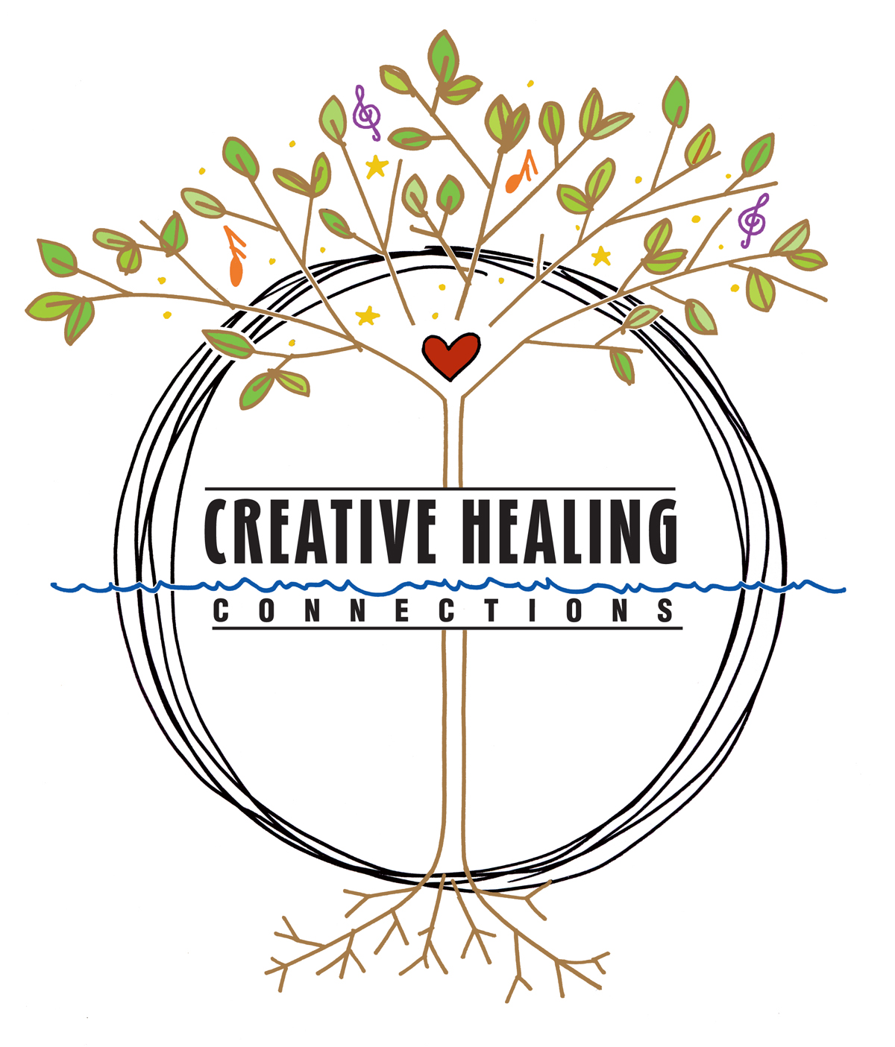
Arts & Healing Retreat 2026

Participant Resources

Practice Audio Recordings
- Guided Awareness (Shavasana)
- Breathing practices
- Pose Sequence
Located at: https://www.creativehealingconnections.org/retreat-resources

Nature Practice Resources
- Forest Bathing: How Trees Can Help You Find Health & Happiness, Dr. Qing Li
- Your Guide to Forest Bathing, M. Amos Clifford
- Healing Trees, Ben Page
- anft.earth (Association of Nature & Forest Therapy) website for many resources
- Association of Nature & Forest Therapy Facebook page for “Simple Practice”
- Healing Forest monthly newsletter with reflections and practices – on Substack

Art & Journaling Resources
- The Artist’s Way and The Artist’s Way Workbook, Julia Cameron
- Back to You Journal, Held & Honest, heldhonest.com*

