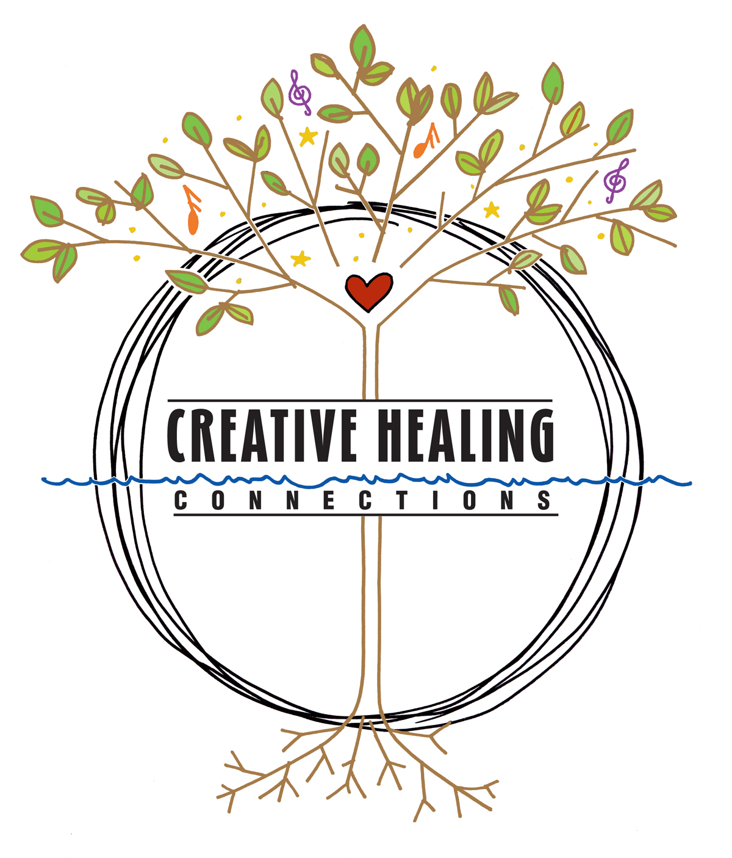
Arts & Healing Retreat 2025

Participant Resources

Practice Audio & Video Recordings
- Find on the Arts & Healing page on the Creative Healing Connections website audio recordings for Heart Song with Beatrice and Guided Awareness with Helene. https://www.creativehealingconnections.org/about-6-1
- Find on YouTube seven videos of Tai Chi practices with Josy, including two seated practices.
https://www.youtube.com/results?search_query=senior+planet+easy+to+follow+tai+chi

Practice Workshops & Classes
- Tai Chi classes with Josy in Saranac Lake and Tupper Lake. www.taichiwithjosyd.com or call Josy at 518-323-6867
- Guided Nature Therapy walks and programs with Helene, private and monthly public programs, https://adirondackriverwalking.com/# or call Helene at 518 637-2963
- Virtual art workshops for social sector professionals with Beatrice, sign up at joincreativeresilience@gmail.com

Gratitude & Thanksgiving Address Practice
- Robin Wall Kimmerer, book Braiding Sweetgrass and You Tube videos talks
- Abraham Hicks, broadcasts, subscriptions including free daily quote on Home page, in-person workshops
- Elizabeth Gilbert, books, events and weekly email Letters from Love newsletter
- Katsitsionni Fox at Ted X Tupper Lake on the Haudenosaunee Thanksgiving Address

Nature Therapy Practice
- Forest Bathing: How Trees Can Help You Find Health & Happiness, Dr. Qing Li
- Your Guide to Forest Bathing, M. Amos Clifford
- Association of Nature & Forest Therapy website has many resources\

Art Resources
- The Artist’s Way and The Artist’s Way Workbook, Julia Cameron

